**TCL COMMANDS**

CREATE TABLE BANK(BANK_ID INT PRIMARY KEY,BANKNAME VARCHAR(20),HEADOFFICE VARCHAR(20),BRANCH VARCHAR(10),BRANCHCODE VARCHAR(10));

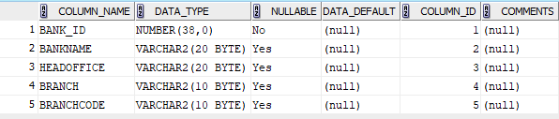

INSERT INTO BANK VALUES(10,'SBI','KOTTAYAM','CHRY',101);

INSERT INTO BANK VALUES(11,'SIB','KOTTAYAM','ERN',102);

INSERT INTO BANK VALUES(12,'BARODA','THODUPUZHA','ETTUMNR',103);

INSERT INTO BANK VALUES(13,'UNION','ERNAKULM','KALOOR',104);

INSERT INTO BANK VALUES(14,'FEDERAL','ERNAKULM','KOCHI',105);

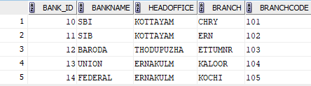

SELECT * FROM BANK;

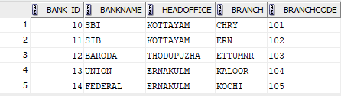

SAVEPOINT A;

DELETE FROM BANK WHERE BANK_ID = 11;

SELECT * FROM BANK;

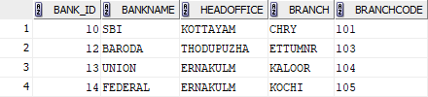

ROLLBACK TO SAVEPOINT A;

SELECT * FROM BANK;

